**Phase 2 - Course-end Project 2**

**FlyAway (An Airline Booking Portal).**

**Developed by:** Narendra Kumar .V

(Emp-ID_10847)

**Project objective:**

As a Full Stack Developer, design and develop an airline booking portal named as FlyAway. Use the GitHub repository to manage the project artifacts.

**Background of the problem statement:**

FlyAway is a ticket-booking portal that lets people book flights on their website.

**Project Overview**

This WebApp is a Software where the users are Entered to book a flight on online. This portal is maintained by Administrator where the admins can change their password and view all the available flights in the database. And also he can add as may flights he can wishThe flights are displayed to the user according to the requirements of the user.It has 2 main Modules user module and admin module where user module is with out login where if you have to access admin portel we have enter credentials.

**Sprint Planning:**

I have Dividing the project into 4 sprints

**1.** In the First Sprint I have designed Database Structure and created tables and understood the features of the project

**2.** In the Second Sprint I have completed the Front end of User and Admin module Using Bootstrap

**3.**  In the Third Sprint I have wrote the backend code for user and admin modules with database connection

**4.**In the Fourth Sprint I have Reviewed the Whole Project for Exceptions and Errors and resolved so that user can have a smooth user friendly experience

**Flow Chart of the Project**

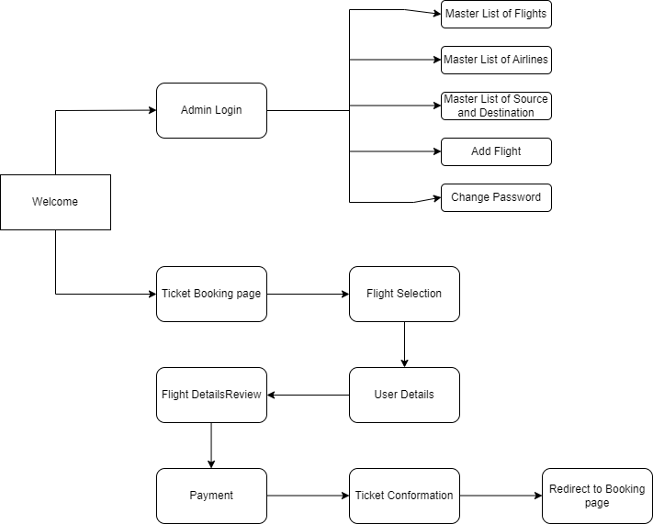

**Java Concepts Used:**

Servlets

JSP Include

Datasource for connecting to the database

Connection

Statements

**Other Concepts Used:**

Bootstrap For Front end

**Project Git hub link:** [Github Flyaway Project](https://github.com/Naren-18/Teksystems_Phase_2_Projects/tree/main/FlyAway)

**Conclusion and Unique Selling Points:**

This is a Prototype Project for Airline booking system

This Project can be enhanced by creating multiple login for Airports like that they will update the flight details in real time and we can also add the charted flights which are available for travel